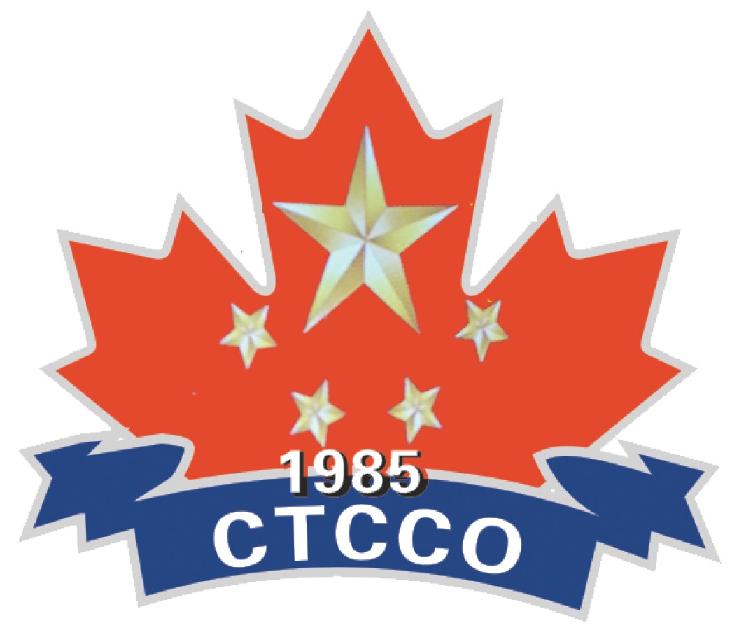
多倫多華人團體聯合總會
The Confederation of Toronto Chinese Canadian Organizations
3601 Victoria Park Avenue, Unit 501, Scarborough, Ontario. M1W 3Y3 info@ctcco.ca

團體入會申請/Membership Application

申請團體信息／Applicant Information
Name of Organization in English:

申請團體中文名稱:

成立年份／Year of Establishment:
注册地址／Address:

城市/City： | 省份/Province: |  | 郵政編碼/Postal Code:

負責人信息/AUTHORIZED MEMBER Information
負責人1/Authorized Member 1:

電話/Tel: |  | 郵箱/Email:
職位/Position:

負責人2/Authorized Member 2:

電話/Tel: |  | 郵箱/Email:
職位/Position:

membership fee $100/year 每年100元
入會日期／Date of Approval

Signatures
申請人謹此聲明贊同本會宗旨與目標及遵守本會章程。
Applicant hereby declares that the organization subscribes to the objectives and aim of the confederation and shall abide by the constitution of the confederation.
申请人签名／Signature of applicant: |  |  |  | 日期／Date:
申请人签名／Signature of applicant: |  |  |  | 日期／Date:

